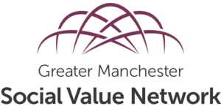

February 2021 Newsletter

This newsletter is about the work of GMSVN and its members and about other social value work going on regionally, nationally and internationally. If you have an event, a publication, an example, a case study or anything else you think network members would like to hear about then we would love to hear from you. Please contact Anna@macc.org.uk

This edition of the newsletter includes:

- Network News……………………………………………………………………………………...1
- Case Studies from the GMSVN members………………………………………………2
- GM Framework 2020…………………………..………………………………………………..4
- Transforming Public Procurement Green Paper ……………………………………4
- New book Generation Impact……………………………………………………………….4
- Video – Bolton Family …………………………………………………………………………..5
- Macc Kindness Directory……………………………………………………………………….5
- Forviva Housing report on homelessness………………………………………………5
- Events and Resources……………………………………………………………………………6

Network News

Post Covid-19 Social Value Manifesto
The pandemic has caused huge suffering in the UK and it has also seen a huge upsurge in organisations working together for the common good at every level, as well as large-scale volunteering and local citizen activism. We need to build on these positive developments. The GMSVN Manifesto is our contribution to how to do that. The manifesto outlines the action that we need to take on: cooperation; brokerage; procurement and commissioning; economic development; devolution; environment; and better business. GMSVN’s future work will focus on developing the ideas outlined in the manifesto and influencing others to make them a reality.

Launch of Manifesto
GMSVN launched its new manifesto at an oversubscribed online conference on 28th January. Speakers included Andy Burnham, Greater Manchester Mayor, Hazel Blears, former Secretary of State for Communities and Local Government), and Rebecca Birkbeck, Director Community & Shared Value, the Co-op. The conference split into workshops to examine and build on each of the proposals within the manifesto and a conference report is being prepared.

Good Practice in Social Value Partnerships
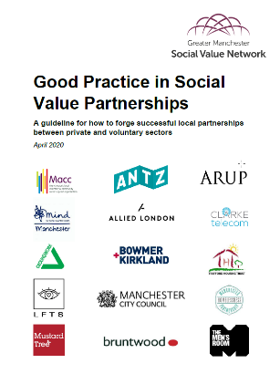
GMSVN in partnership with Macc and Manchester Homelessness Partnership have produced a guideline for how to forge successful local partnerships between private and voluntary sector organisations. The recommendations were developed at a conference held in March 2020 attended by a mixed group of charities, businesses and brokerage bodies but publication was delayed due to the covid-19 crisis. The top three priorities identified by the group were: creating long-term relationships; focusing on the cause; setting clear and realistic goals. There are a further set of recommendations under the three headings of forming relationships; maintaining relationships; and ending relationships. It is the first in a set of proposed publications to expand on the proposals outlined in the GMSVN Manifesto.

Case Studies from the GMSVN members.
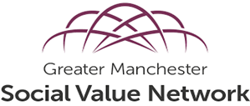
As a network, we have over 300 members from all sectors across Greater Manchester working to promote and incorporate social value principles in to their organisations and inspiring organisations they work with. In May 2020, the GM Social Value network put a call out to its members to share any case studies detailing how covid-19 has impacted their work and specifically how they have had to change or adapt their service to support those in need. Below are only a few of the case studies ( apologies that we could not include all the case studies we received) from our members. We hope these short case studies highlight social value in action.

Manchester NSL Civil Enforcement Officers.
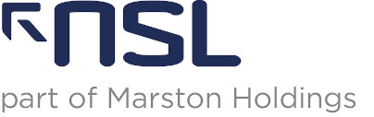
NSL Civil Enforcement officers in Manchester have been working with Manchester City Council to support local residents from the beginning of the pandemic. These officers volunteered to support council services to provide 600 deliveries of food, which equates to over 1,000 meals to Manchester residents shielding due to the virus. Officers often worked into the night supporting the community by being out on the street to keep the roads open for emergency vehicles, waste collections and essential deliveries. This work has played a valuable role in maintaining road safety and highlight true partnership in action.

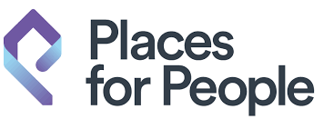
Places for People
Places for people Housing association have worked with 24 food banks across the country making a donation to each of them and agreeing a direct referral arrangement between our staff and the relevant foodbank . This will be reviewed and I expect ongoing discussions post covid. They have also made over 80,000 welfare calls to our customers and followed these calls with actions depending on the circumstances.

Turn up the Value

Turn up the value founder, Karen Smith shares her experiences of running a business, juggling childcare responsibilities and supporting her community during the pandemic. “As a micro business juggling the responsibilities of a young family, I have not been able to actively respond to the covid-19 as I would’ve like. This caused me some guilt until I remembered that social value is not always about time or resources freely given. It is adjusting the way you think and act so that you are guided by your values and do what you can. I realised that I can respond to Covid-19 by checking in with friends and colleagues and offering to listen and support. I can build strong networks, bringing together like-minded businesses so that we are ready to build back better. I can bid for work that will make a difference in communities who will feel the effects of this pandemic for years to come. I can maintain my own wellbeing and I can learn from this crisis and grow my business to be the best it can be. Through my consultancy work with the Woodland Trust, I have gained a new found respect for the wellbeing benefits of being outside in nature. It is not a coincidence individuals, communities and businesses seem to be placing a higher value on the outdoors and as a consequence I am witnessing a growth in opportunity for the Woodland Trust and the enterprises I work with at the Smithills’ Estate. There is renewed interest from schools for the outdoor spaces we can offer. Outdoor education providers have gained countless new customers by taking their offer online to support families’ offline. I am so excited to be building new partnerships to respond to these opportunities. It seems that this pandemic has brought people together in a completely unexpected way and the potential for impact is huge.

Manchester Deaf Centre

An eight-year-old girl has formed an unlikely bond with her delivery driver who is deaf by communicating with him in sign language during the pandemic. Her proud mother from Ashton-under-Lyne, captured the moment her daughter Tallulah stood near her garden gates and greeted Hermes delivery driver Tim Joseph (who Manchester Deaf Centre supported into his current role) with the words 'have a good day' in sign language. The surprised delivery worker, who has been delivery parcels on the street twice a week, smiles at the little girl before giving her a thumbs up.

In addition, Manchester Deaf Centre clients contacted them in desperation. He was isolating, had run out of food and money completely and had no family to collect groceries for him. His friend was informed and initially dropped off a small food parcel for him to get by temporarily but could not do this in the long term. Manchester Deaf Centre contacted Manchester Community Central Hub who advised that vulnerable people, living on their own, could be provided with a food parcel. After answering a few questions (via our interpreter), the individual received a food parcel that week and for several weeks after.

Boo coaching and consulting.
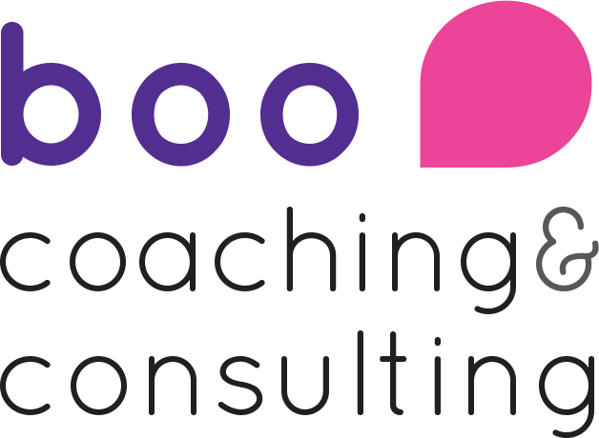
After initially participating in the general widespread panic about how we would survive this pandemic as small business, Team Boo were approached by Southport & Ormskirk NHS trust to deliver ongoing wellbeing support to staff across their two hospital sites. They agreed to do this at cost, to keep themselves afloat but minimize the impact on the NHS. Since the end of March, all of their energy and resources have been devoted to the wellbeing of those on the frontline fighting Covid-19 in the North West - at Southport & Ormskirk, but also at the Royal Bolton Hospital where we’ve offered 30 free hours of support. This has been anything from providing cups of tea and a listening ear, to leadership coaching, to coordinating donations from the public, to morale-boosting social media. We are immensely proud to have been able to contribute to local efforts in this way.

Greater Manchester and National News

GM Framework 2020
The Greater Manchester Combined Authority together with the Mayor’s Office have developed a Greater Manchester Social Value Framework. Among other things, the framework can be used as a talking point in corporate or business planning; a checklist for commissioning; and a guide for development of procurement strategies and social value policies. The 6 priorities identified in the framework are: provide the best employment that you can; keep the clean air in Greater Manchester; create the employment and skills opportunities that we need to Build Back Better; be part of a strong local community; make your organisations greener; develop a local GM-based resilient supply chain. The GMSVN Steering Group fed into the proposals as they were being developed.

Transforming Public Procurement Green Paper
The government published a green paper on post Brexit procurement rules on 15th Dec 2020. The consultation runs until 10th March. The paper makes numerous references to social value and sends a clear message that public procurement teams should take a broad view of value for money. It is proposed that buyers will be allowed to “include criteria that go beyond the subject matter of the contract and encourage suppliers to operate in a way that contributes to economic, social and environmental outcomes on the basis of the ‘most advantageous tender’”, MAT rather than MEAT (Most Economically Advantageous Tender). Additionally, it is proposed that public procurement should support strategic national priorities. These priorities will be published in a National Procurement Policy Statement. The paper makes a raft of other proposals about procurement mechanisms which will also impact on the ability of public authorities to secure social value.

Book - Generation Impact: International Perspectives on Impact Accounting.
Greater Manchester Social Value Network chair Matthew Baqueriza-Jackson and steering group member Anne Lythgoe have written a chapter for a new book called ‘Generation Impact: International Perspectives on Impact Accounting’, edited by Adam Richards. Generation Impact brings together lessons from both developed and developing economies, shares current best practice and suggests future trends in impact accounting. Their chapter is on ‘Social Value in Commissioning’. There is a discount code to claim 25% off the retail price of this book for GMSVN members. For more information and to purchase the book go to https://books.emeraldinsight.com/page/detail/Generation-Impact/?K=9781789739305

Video – Bolton Family
The Bolton Family are a partnership are a collective of public, private and voluntary organisations who work together to make Bolton the best place to live, work and prosper. They have made a video highlighting the fantastic work the Bolton family partnership organisations are doing to support their local communities during covid-19. Seddon Volunteers support Bolton Foodbank during Coronavirus outbreak

Macc, organisational directory
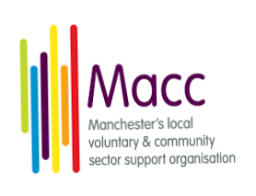
Macc’s Winter Kindness Campaign wants to ensure everyone has access to up to date information about what support is available from VCSE sector organisations in Manchester. The directory will include details of those wishing to help to support the work of local community organisations to ensuring necessary information is available to those who need it. Macc’s directory is a working document and will be expanded with much more detailed information about the support and services on offer, opening times, contact details and information about what organisations need as, such as volunteer support or asks for donations and fundraising campaigns. For more information or to register your organisation on the online directory by emailing Michelle on Michelle@macc.org.uk

Forviva Housing Report- Covid 19 wellbeing Response
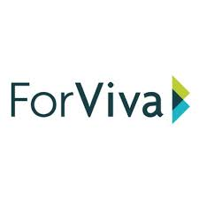
Forviva Housing have developed a report detailing how they have supported the homeless community in Salford during the pandemic. They provided the use of vacant properties as temporary accommodation. They ensured that all accommodation provided was fully furnished and liveable in immediately. Whilst this is a temporary measure due to the current need, Forviva are working with the local authority to ensure this is the start of longer-term solution for vulnerable residents to have access to safe, secure, long-term accommodation. The report explains in more detail Forviva’s approach to supporting homeless residents and those in insecure accommodation as well as how they are supporting Salford residents to combat isolation and improve wellbeing during the pandemic.

Events and resources

National Social Value Conference 2021
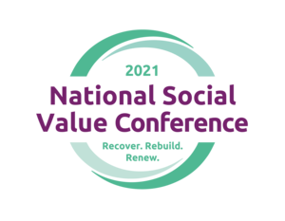
The 4th Annual National Social Value Conference 2021 will be held virtually on the 23-24 February 2021.The conference brings together experts and practitioners from the public and private sectors to share good practice and innovative ideas about how to embed social value into commissioning, procurement and delivery. This year the conference theme is ‘Recover, Rebuild, Renew’ and will provide an opportunity to discuss how we can support our communities to recover and renew in a post-COVID-19 world.

Webinar: The Way Forwards 23rd Feb, Bolton CVS

Bolton CVS will shortly be hosting a webinar to look at social value, how to measure it and what the next steps are for organisations in building back better. As a response to the huge change and unpredictable times we are currently, experiencing there seems to be a growing consensus that this is the right time to do something different. This webinar will be held between 4.30pm – 6.00pm on Tuesday 23rd February 2021, led by Adrian Nottingham, Social Value, Quality and Impact Officer, Bolton CVS.

Webinar: Maximising Impacts: from rhetoric to reality, 24th Feb, Social Value International
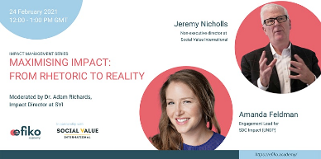
Jeremy Nicholls, SVI Non-Executive Director and Amanda Feldman, Engagement Lead for SDG Impact (UNDP) will talk about “how to make impact maximisation a reality”. This is one of a series of webinars about impact management.

SAN Virtual Roadshow - Build Back Better - a new era for Social Accounting, 28th April, Social Audit Network
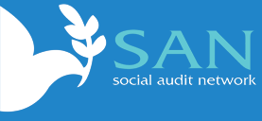
This 1 hr workshop will explore the value of preparing and publishing social accounts for organisations in the social economy, as they recover from the rigours of Brexit and the Covid pandemic. There will be a keynote speaker who will explain why they see a new era for social accounting.

Conference: Powering Social Value through recovery, Mar 11th, MCC &CLES

The purpose of this year’s event is to showcase some of the great work being undertaken in Greater Manchester and wider. It will include: a keynote from Neil McInroy (CLES); an update on social value activities; and a choice of workshops.

Greater Manchester Social Value Network membership.

If you’re new to the Social Value Network or to social value in general, here is some information you might find useful:

Social value is the term used to describe the importance of beneficial outcomes, which are not usually fiscal or economic. An organisation, group or business can benefit from embedding a positive change in the way they work that improve the happiness, wellbeing, health, inclusion, empowerment, poverty and environment of their employers, staff and clients. The idea is to create a happier, healthier workforce and population to enable us all to benefit from better work life balance, overall health benefits, better job satisfaction and productivity.

The Greater Manchester Social Value Network (GMSVN) aims to influence stakeholders, policy and strategy at the GM level around social value. The network undertakes three activities:

1. It collects information, evidence and examples of social value across Greater Manchester.
2. It supports organisations across all sectors to deliver more effective social value policy, practice and outcomes.
3. It uses the skills and knowledge of the network to influence the behaviour of the ranger of individuals and organisations with a stake in social value.

If you would like to become a member of the GMSVN, submit news items, or have any questions about the network please contact Anna Tate at Anna@macc.org.uk

